**Introduction to Acids & Bases Webquest**

Please complete this webquest independently to help with your understanding of concepts. All answers should be written in your own words to help with your understanding of concepts.

**Solutions**

1. Go to <http://www.chem4kids.com/files/matter_solution.html>
   1. What is the difference between a homogenous and a heterogeneous mixture?
   2. What is a solution?
   3. Give an example of a solution that does not involve a solid being dissolved in a liquid. Explain how this is a solution.
   4. Define the following terms:
      * Solute
      * Solvent
      * Solubility

**Defining Acids & Bases **

1. Go to <https://www.youtube.com/watch?v=ZiokqP0aZ1E>
   1. How does the Arrhenius theory define acids and bases?
   2. What is the main problem with the Arrhenius definitions?
   3. How does the Bronsted-Lowry theory define acids and bases?

**Properties of Acids & Bases**

1. Go to <http://chemistry.about.com/od/acidsbases/a/acidsbasesterms.htm> Scroll down to
   1. **Properties of Acids.** Complete the following sentences for **Acids**
      * Taste _________________
      * Changes litmus from blue to _____________.
      * Solutions are __________________________ (conduct electricity)
      * React with bases to form ___________________ + _______________.
      * Create _______________ gas when reacting with an active metal.
   2. **Properties of Bases**
      * Taste _____________________.
      * Feels _______________________________.
      * Don’t change the color of __________________________.
      * Solutions are _____________________________ (conduct electricity).
      * React with acids to form ____________________ and ___________________.
   3. Give four examples of Common Acids
   4. Give four examples of Common Bases:
2. Complete the Venn Diagram below

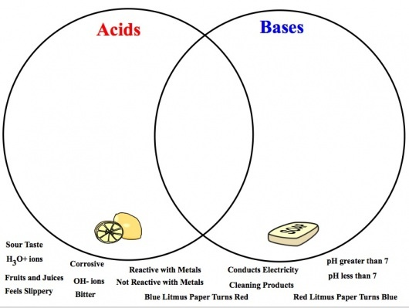

**The pH Scale**

1. Go to <http://chemistry.about.com/od/acidsbases/a/phtable.htm> and <http://www.visionlearning.com/en/library/Chemistry/1/Acids-and-Bases/58>
   1. What is pH?
   2. What is the pH range of **acids** ______________________
   3. What is the pH of a **neutral** substance ______________
   4. What is the pH range of **bases** (alkalis)__________
   5. What is the formula for calculating pH?
   6. What does the symbol [ ] mean?
   7. Use information from the sites above and list the following substances from lowest pH to highest pH.

|  |  |  |
| --- | --- | --- |
| **Substance** | **pH** | **pH lowest to highest** |
| Pure Water | 0 | HCl |
| Wine and Beer | 1 |  |
| Milk of Magnesia | 2 |  |
| Ammonia | 3 |  |
| Lime (Ca(OH)2) | 4 |  |
| Milk | 5 |  |
| Tomatoes | 6 |  |
| Egg Whites | 7 |  |
| Baking Soda (NaHCO3) | 8 |  |
| Battery Acid | 9 |  |
| NaOH | 10 |  |
| Apples | 11 |  |
| HCl | 12 |  |
| Lemon Juice | 13 |  |
| Drano | 14 | NaOH |

**What Have YOU Learned?**

1. Go to <http://chemistry.about.com/library/weekly/blacidquiz.htm> and take the quiz.

Place your score here __________________.

1. Look at the picture to the below.

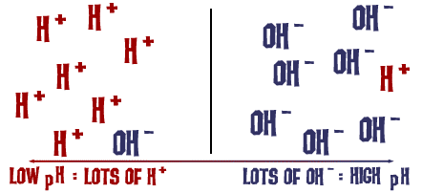

* 1. Identify the side that is acidic.
  2. Explain why this side is acidic
  3. Identify the side that is basic
  4. Explain why this side is basic

**VIRTUAL LAB**

1. Go to <http://www.glencoe.com/sites/common_assets/science/virtual_labs/E22/E22.html> read the directions and complete the acid/base testing simulation. Click print and save your virtual lab as a PDF to show Mrs. Page in class.